MTH 1240 Statistics
Concept Check #3

College Graduate Competencies: This assignment will assess CGC #4: "Create, solve, and interpret appropriate equations in the curriculum.” & CGC #8: "Communicate mathematics orally and/or in written form."

The following data was collected using a simple random sample and represents student annual income reported on last years tax return.

Student ID | Annual Income ($) | Student ID | Annual Income ($)
1 | 12,900 | 9 | 18,800
2 | 10,800 | 10 | 15,800
3 | 43,900 | 11 | 9,700
4 | 21,000 | 12 | 19,100
5 | 16,500 | 13 | 50,600
6 | 17,300 | 14 | 22,200
7 | 14,800 | 15 | 9,900
8 | 6,900

Use the data above to answer the following questions. Make sure that you show all of your work for each question.

- (2 point) Find the sample mean of the annual income. Show your work using the equation below. Be sure to include the appropriate units in your answer.

$$\overline{x}=\frac{\sum{x_{i}}}{n}=$$

- (3 points) Find the median annual income and interpret this value using a sentence in context. Do not repeat the procedure for finding the median but interpret this value in a meaningful context. Be sure to include the appropriate units in your answer.

$$M=$$

- (2 points) Below is a histogram of the annual income data. Why is the mean so much larger than the median? Explain.

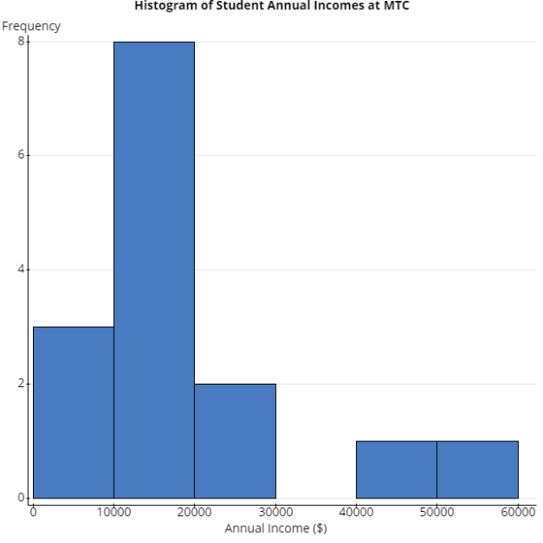

- (2 points) Why is it better to report the median, instead of the mean, as a typical measure in this case?

- (3 points) Calculate the sample standard deviation by hand. Show all work. The table below is helpful to organize your work. Fill in the table and fill in the equation below.

$$x$$ | $$x-\overline{x}$$ | $${\left(x-\overline{x}\right)}^{2}$$
 | $$\sum{{\left(x-\overline{x}\right)}^{2}}=$$

$$s=\sqrt{\frac{\sum{{\left(x-\overline{x}\right)}^{2}}}{n-1}}=$$

- (1 point) What is the units for the sample standard deviation found above?

- (2 points) What is the five-number summary for this data? Fill in the table below.

Minimum
Q1
Median
Q3
Maximum

- (1 point) What is the IQR? Show your work.

- (1 point) Find the lower and upper fences as described on page 165.

- (2 points) Do we have any outliers using the lower and upper fences? If so, what are they? How do you know?

- (3 points) Draw a box and whisker plot (a.k.a. box plot). Be sure to include an axis, appropriate titles, etc.

Math College Graduate Competency (CGC) Rubric
This assignment will be holistically evaluated using the following rubric items.
